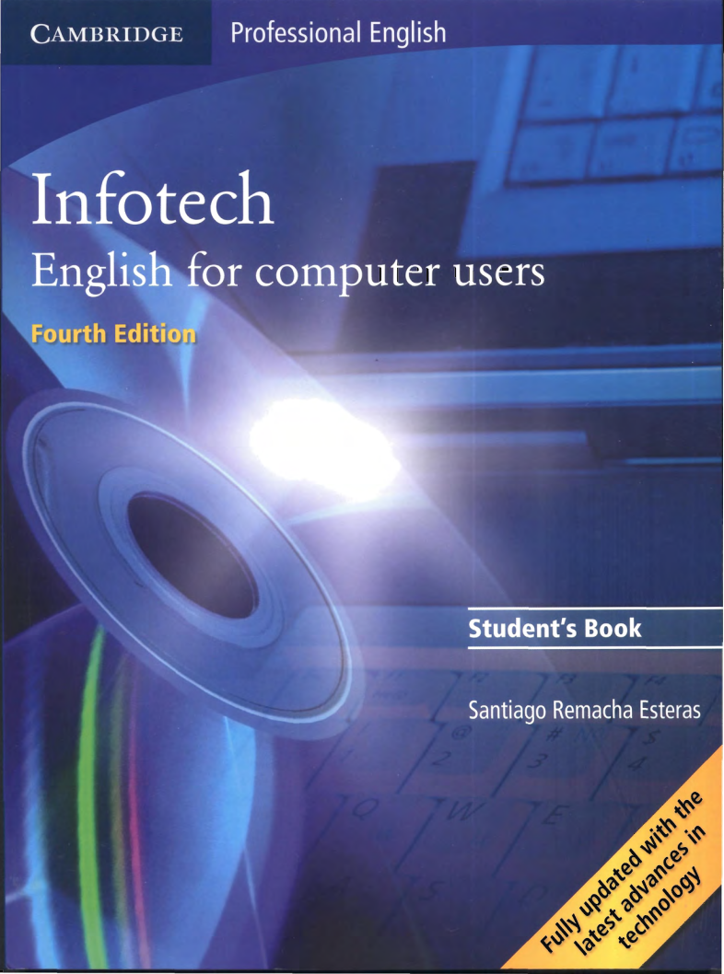


Task 1
- Translate the text.
- Complete the exercises.
- Make up the glossary of the words given in the bold font.
Aim of a glossary is a dictionary of terms specific to a certain subject. You can see video how to compile it: https://www.youtube.com/watch?v=8CdTGtVltDQ
Glossary

No | Term | Definition | Term | Definition
1 | Abelian group | A group in which the result of applying the group operation to two group elements does not depend on their order. | Translation | Translation


